**Admin can update or delete any post**

**/src/post/SinglePost**

Just like we added buttons for admin to edit or delete user on Profile component. We will do something similar in this SinglePost component. Let's put edit/delete buttons for admin right below the existing buttons inside renderPost()

<div>

{isAuthenticated().user &&

isAuthenticated().user.role === "admin" && (

<div class="card mt-5">

<div className="card-body">

<h5 className="card-title">Admin</h5>

<p className="mb-2 text-danger">

Edit/Delete as an Admin

</p>

<Link

to={`/post/edit/${post._id}`}

className="btn btn-raised btn-warning btn-sm mr-5"

>

Update Post

</Link>

<button

onClick={this.deleteConfirmed}

className="btn btn-raised btn-danger"

>

Delete Post

</button>

</div>

</div>

)}

</div>

Now you can edit delete any post as an admin.

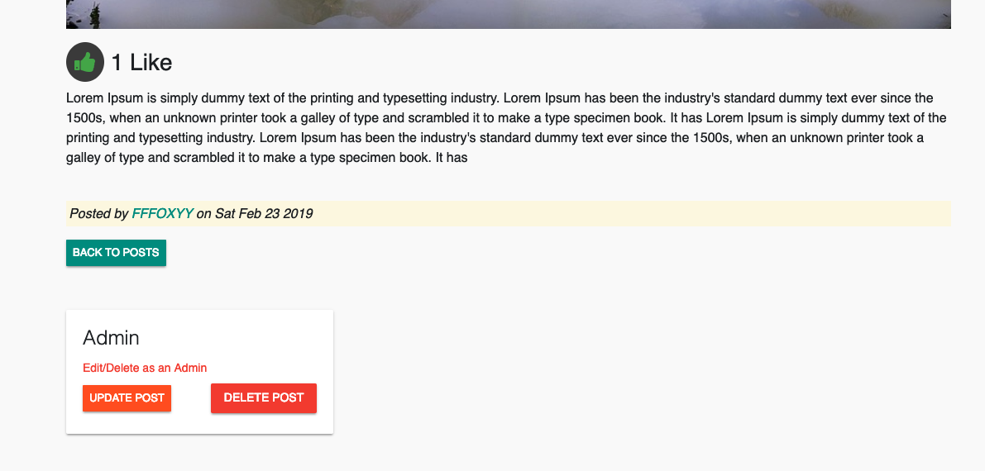

**Let's tidy things up!**

When you are editing other people's profile as admin, once you are done editing, you will see the profile name in the navbar changed to the user whose account you just updated.

Thats because when the user profile is updated, we update the local storage and The Navbar's profile info is based on localStorage user info.

To avoid this from happening, you can update clickSubmit() in user/EditProfile.js

Keep in mind that this clickSubmit() uses updateUser() which we have created in user/apiUser.js

Lets apply a conditional in EditProfile component's clickSubmit()

**/user/EditProfile.js**

clickSubmit = event => {

event.preventDefault();

this.setState({ loading: true });

if (this.isValid()) {

const userId = this.props.match.params.userId;

const token = isAuthenticated().token;

update(userId, token, this.userData).then(data => {

if (data.error) {

this.setState({ error: data.error });

// if admin only redirect

} else if (isAuthenticated().user.role === "admin") {

this.setState({

redirectToProfile: true

});

} else {

// if same user update localstorage and redirect

updateUser(data, () => {

this.setState({

redirectToProfile: true

});

});

}

});

}

};

Okay. This is it! You have admin dashboard and the edit/delete functionalities implemented for admin. If you have encountered any issues, feel free to post your questions in Q&A section of this course.

Also checkout the source code of this project. You can also checkout different commits based on which section you are working on. The instructional video and link to Github repos are in the last section of this course.